Creación de un Servicio Web con .Net

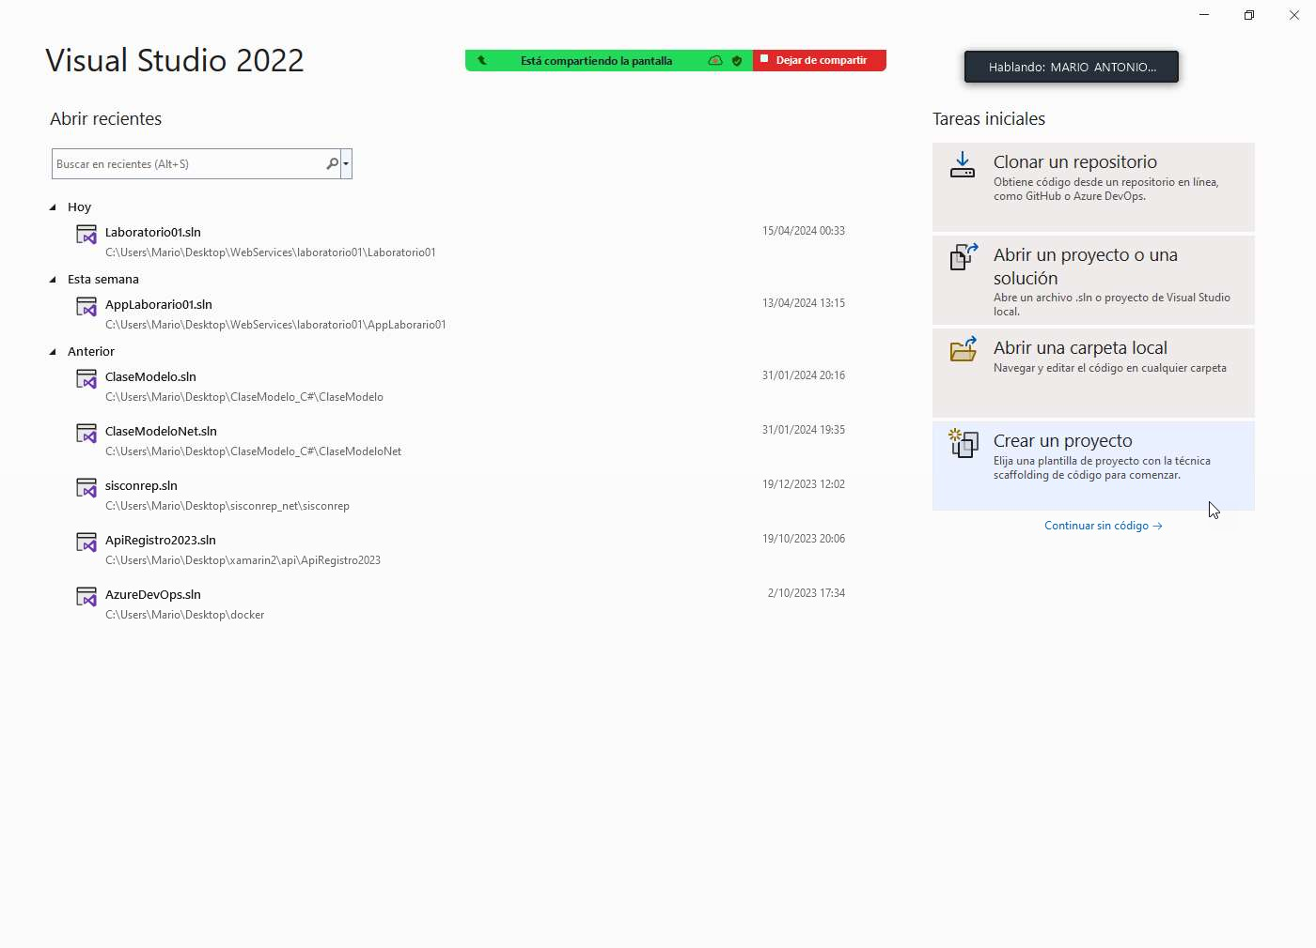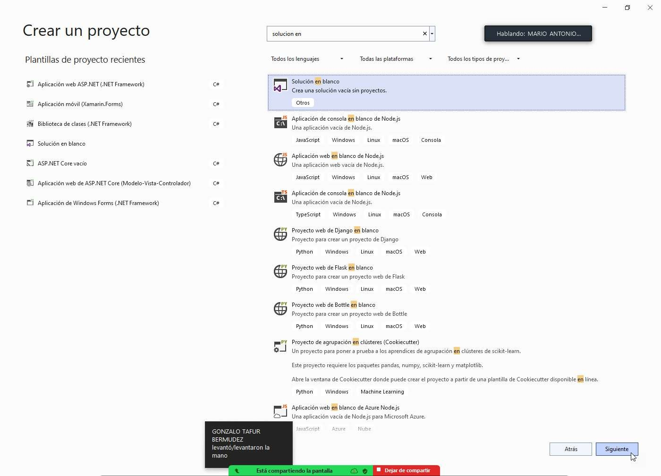

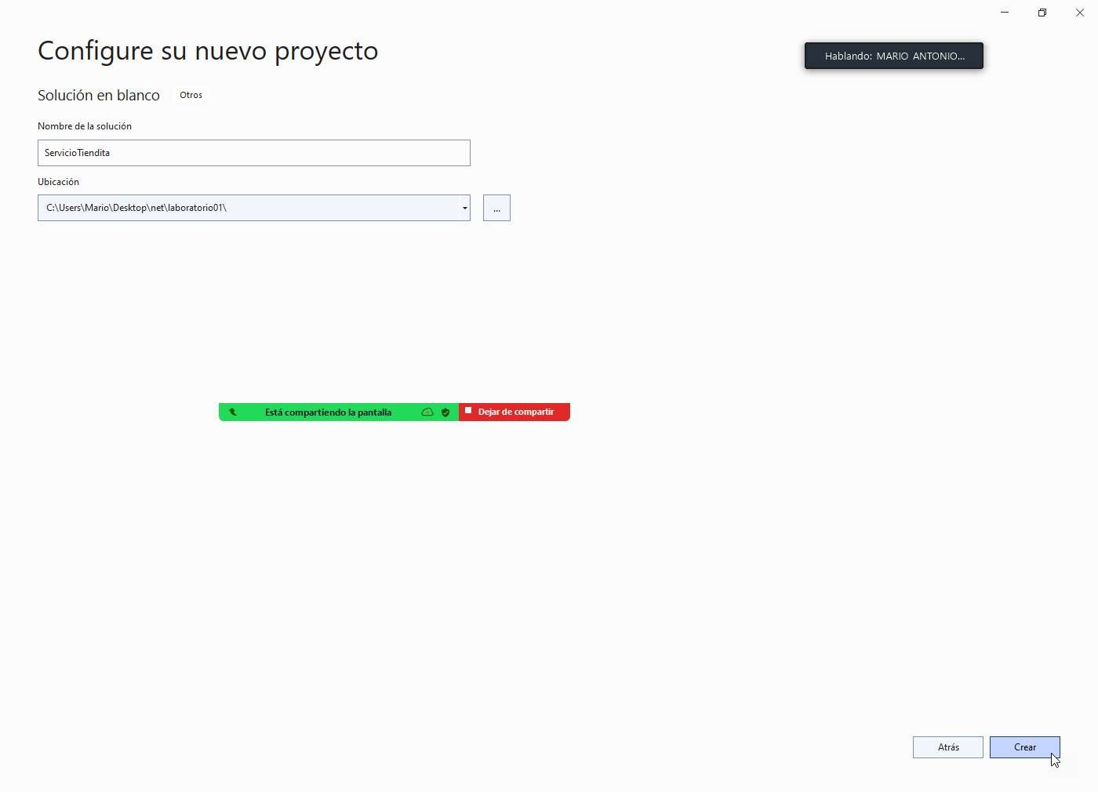

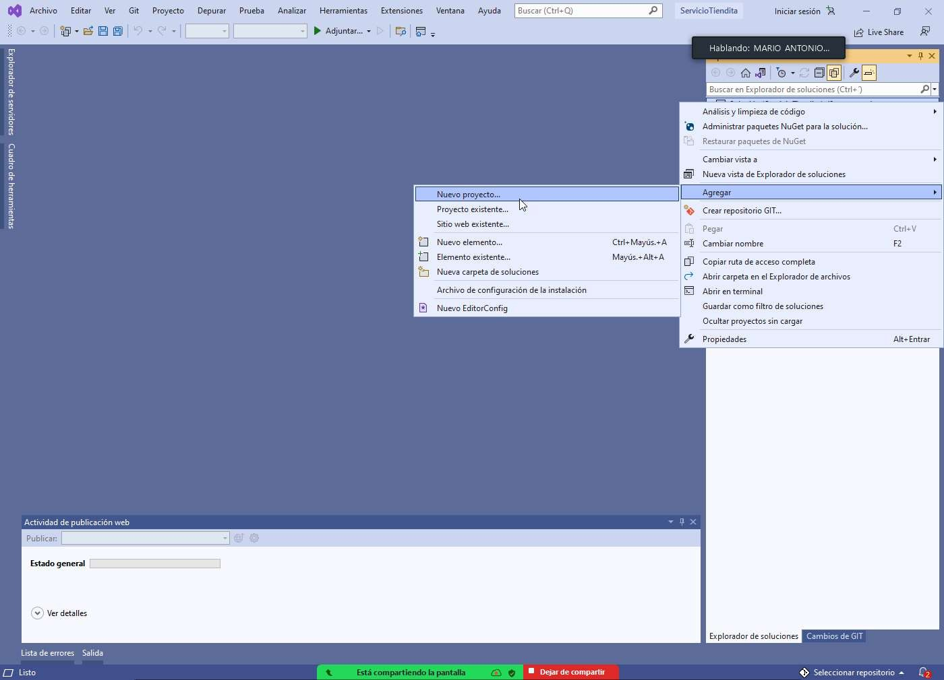

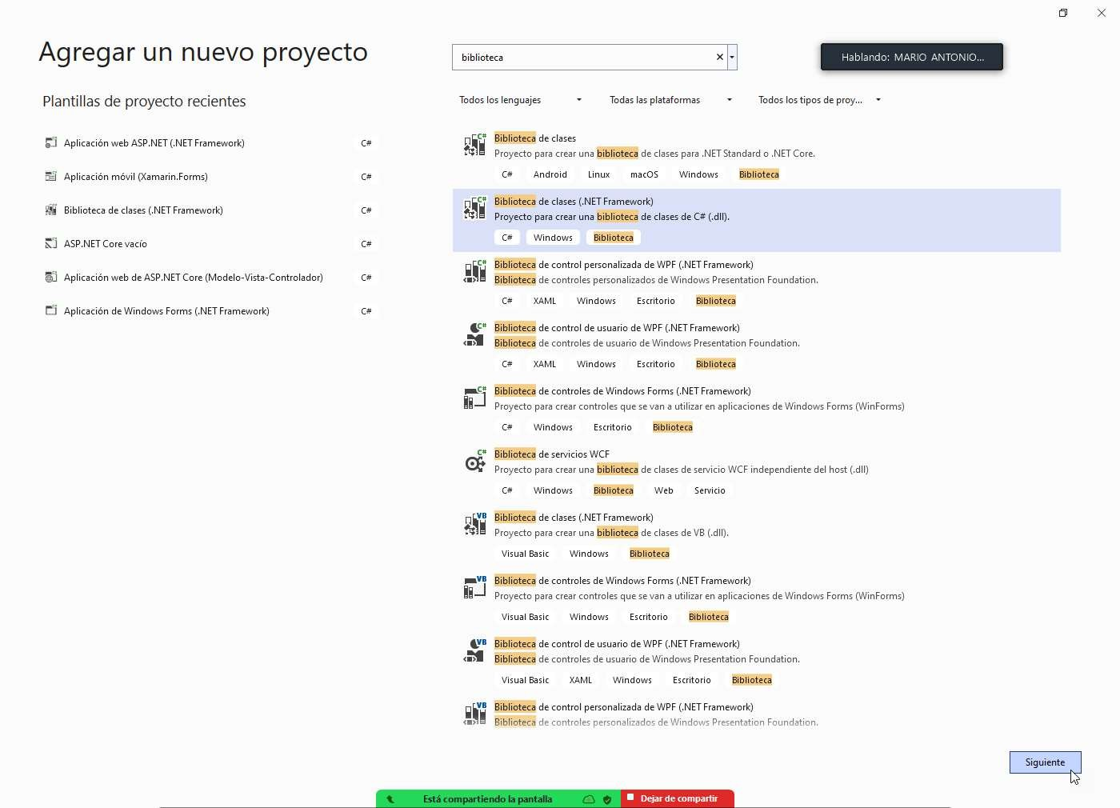

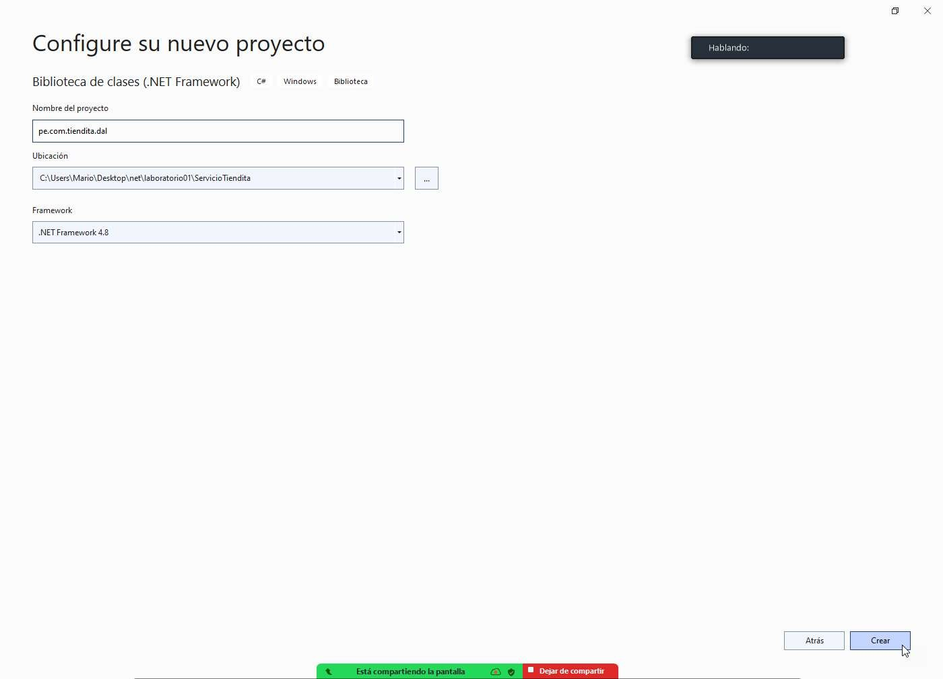

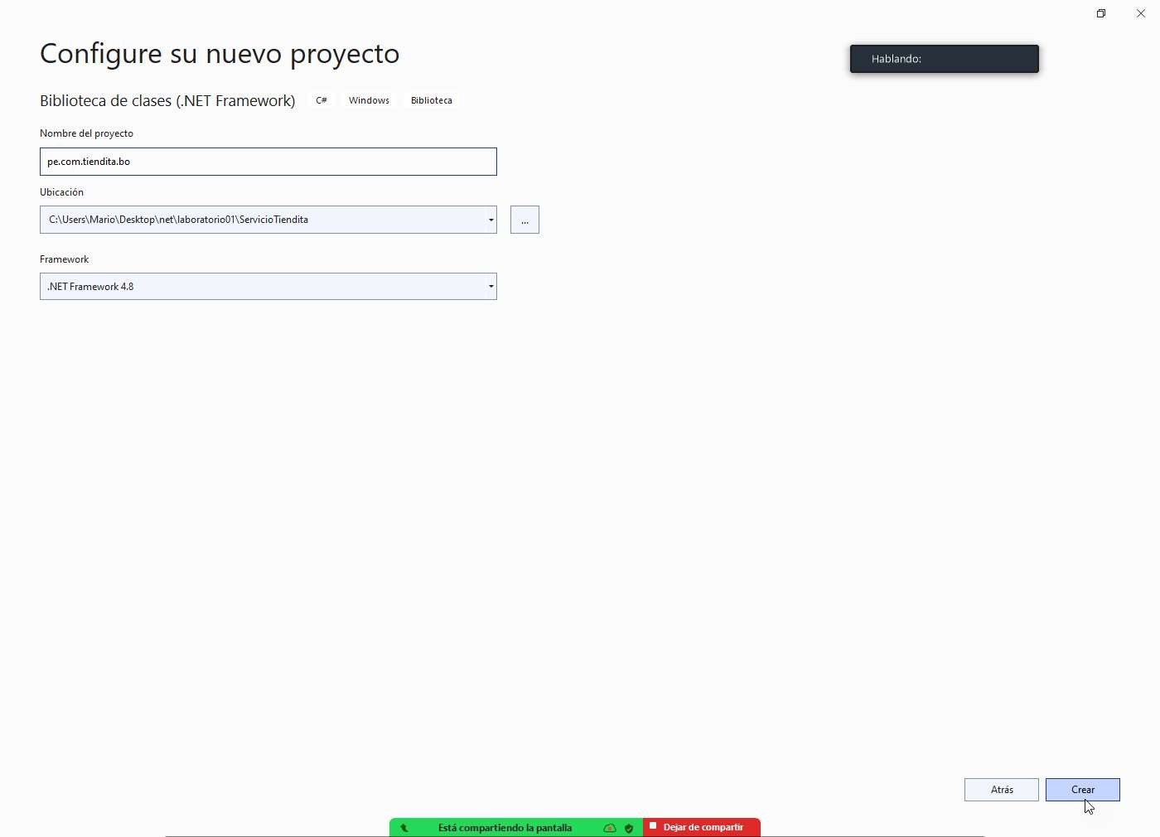

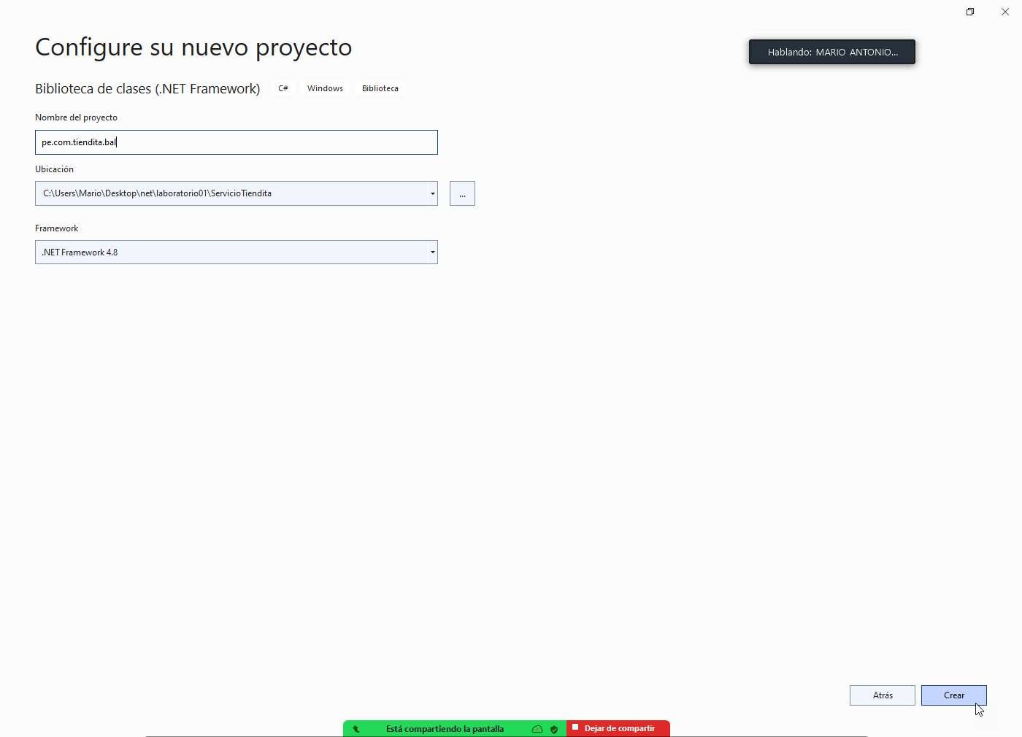

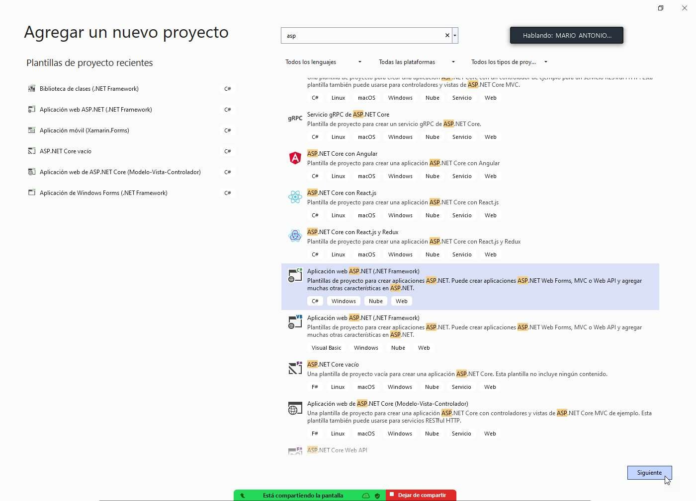

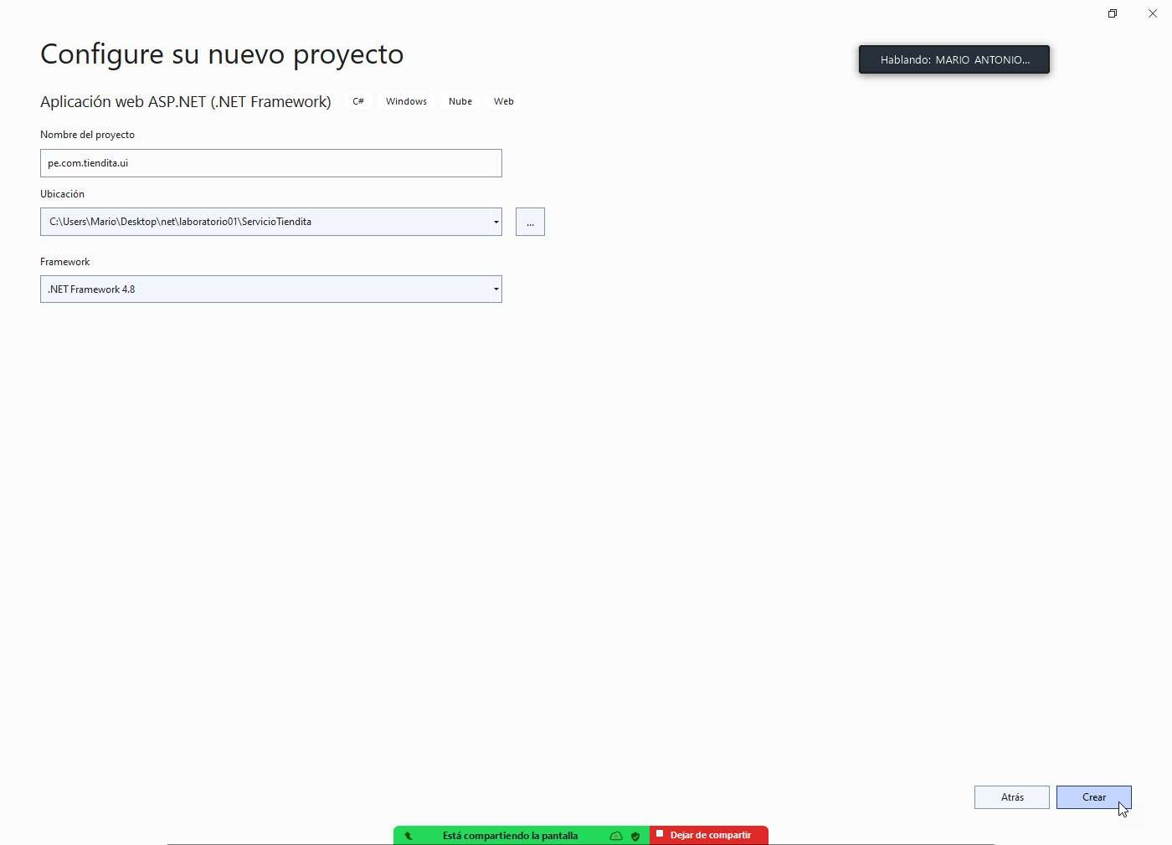

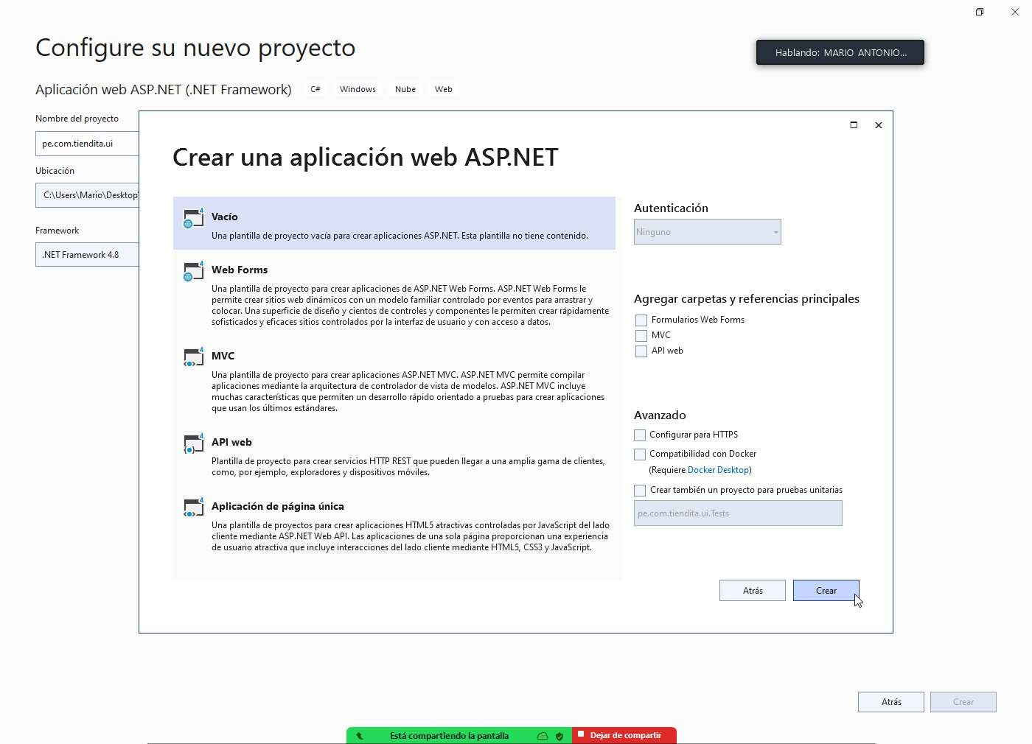

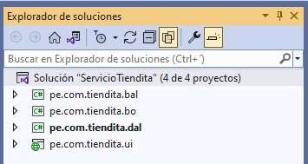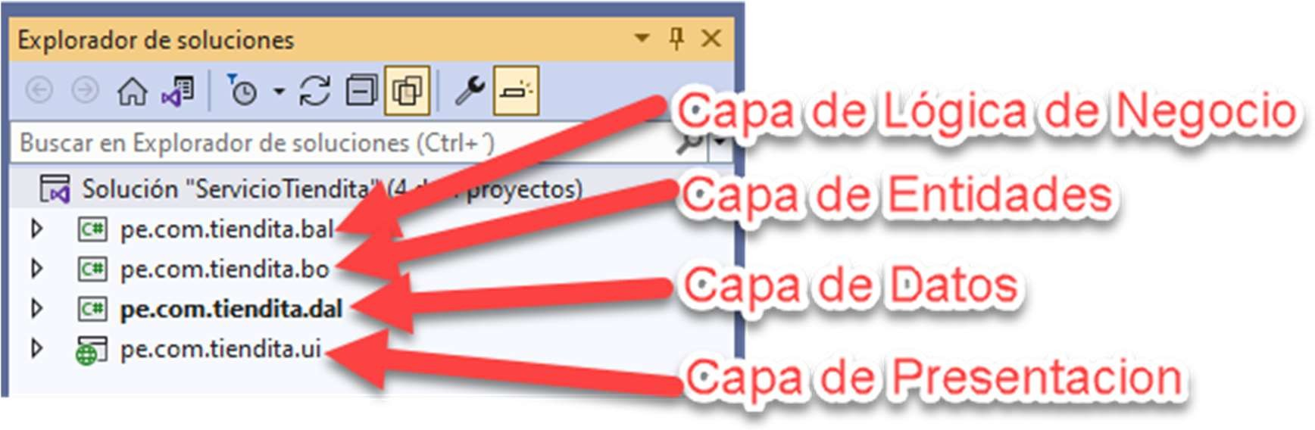

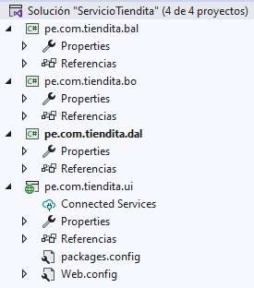

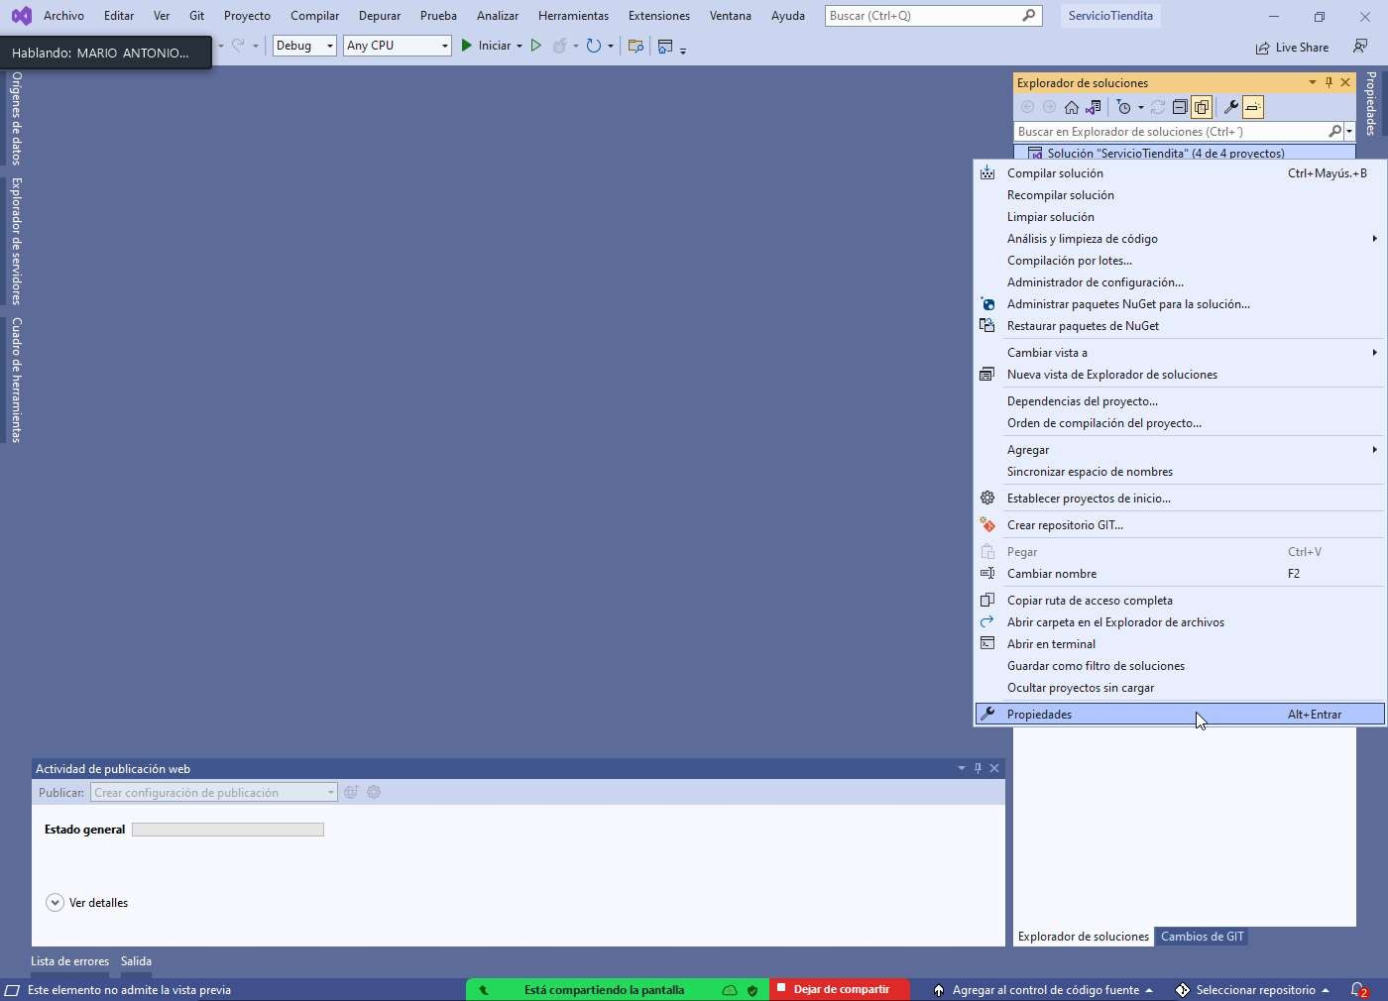

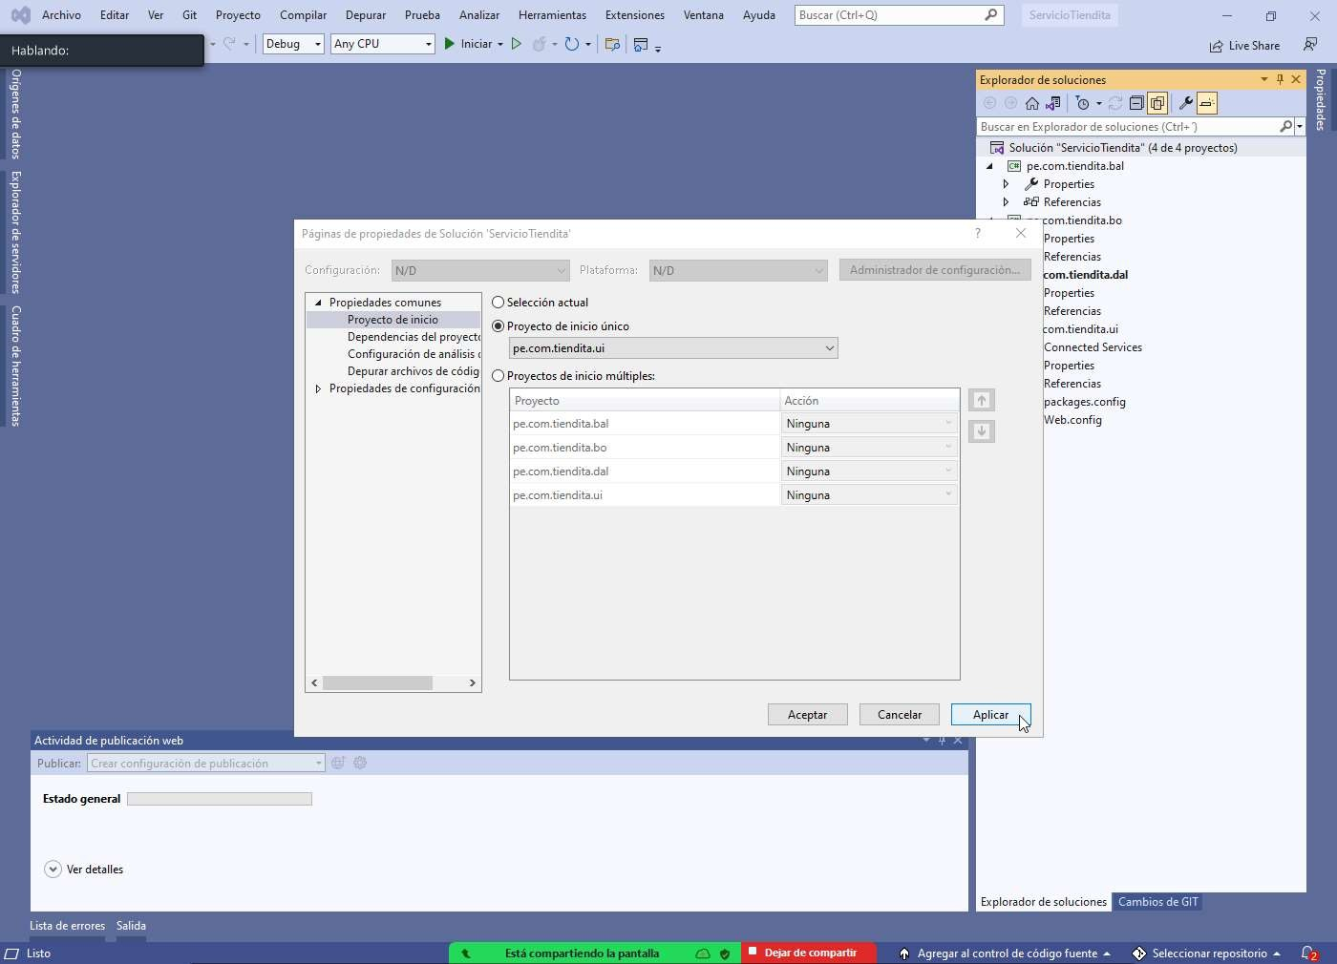

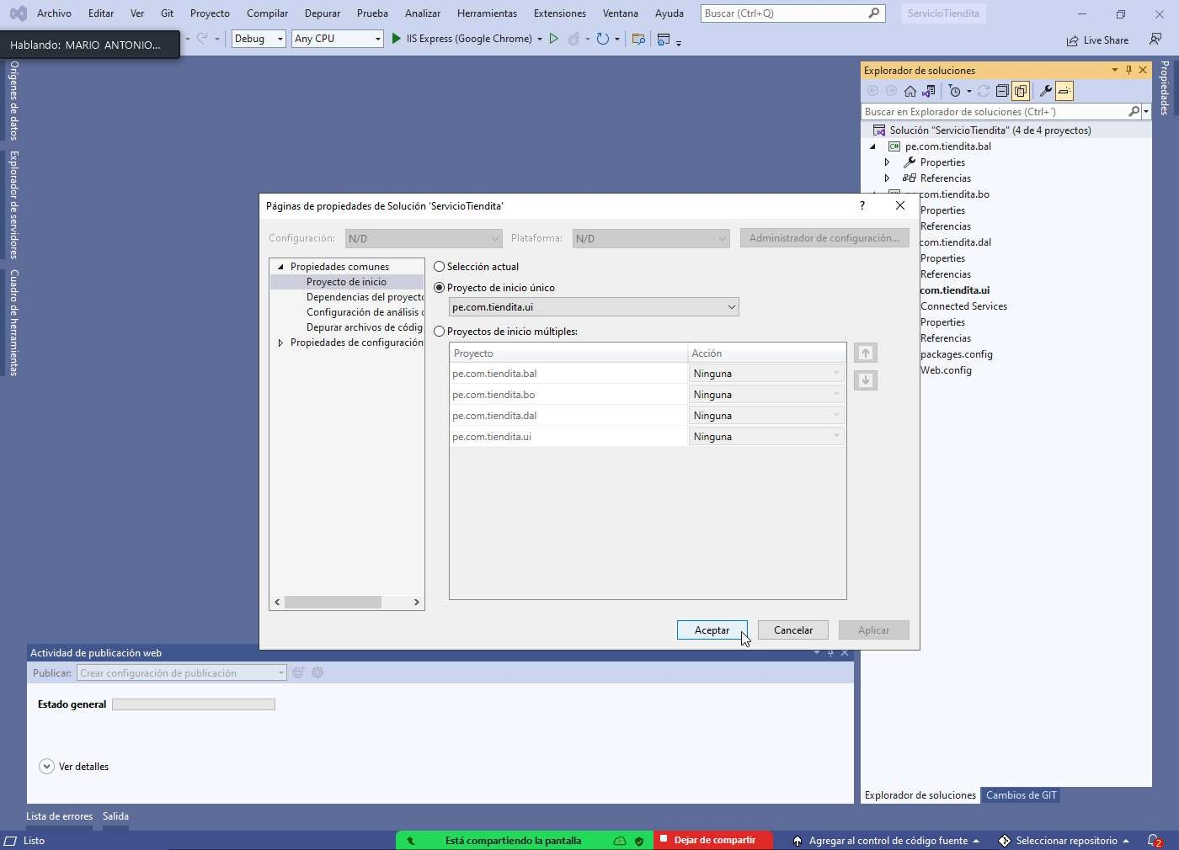

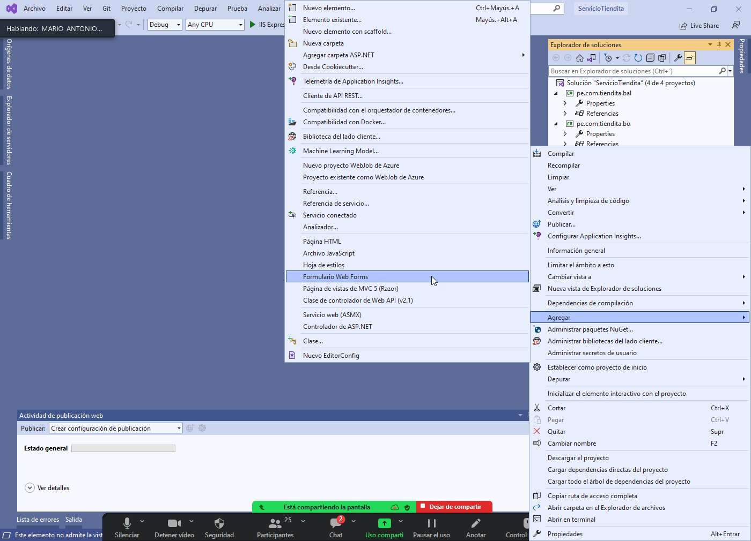

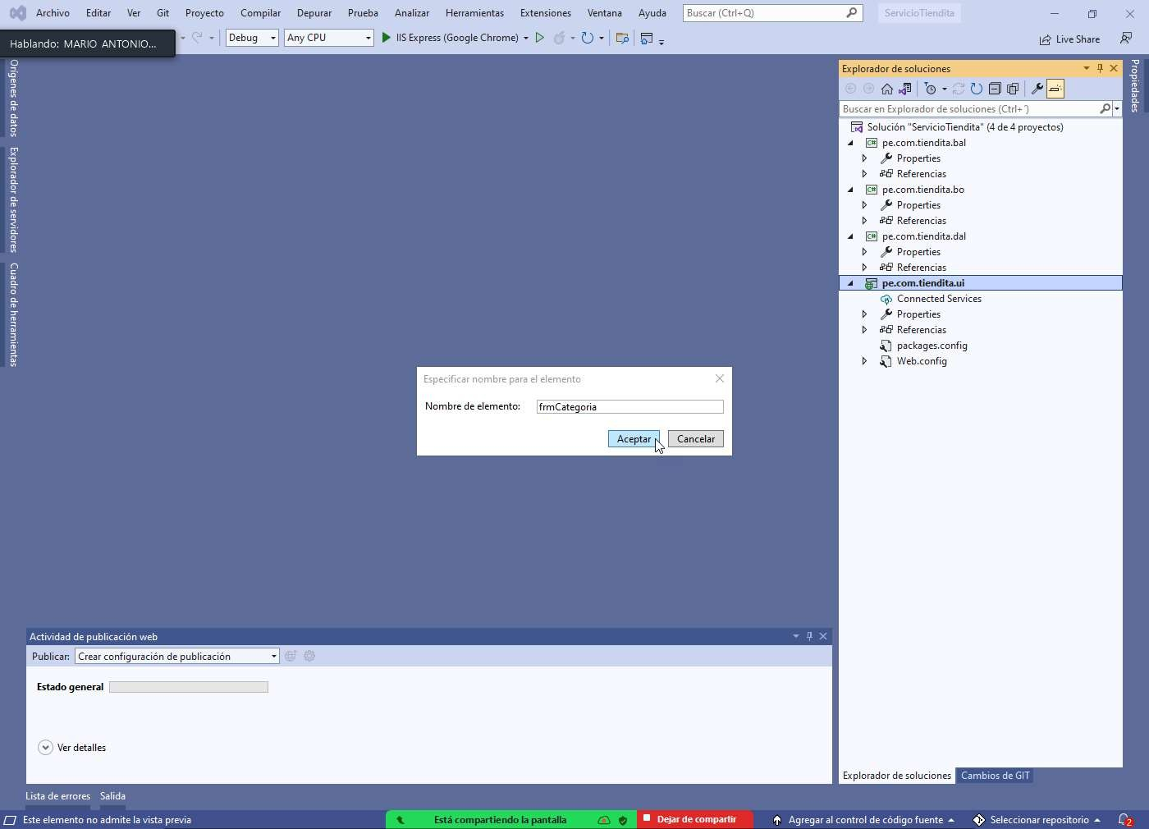

# Bdtiendita.sql

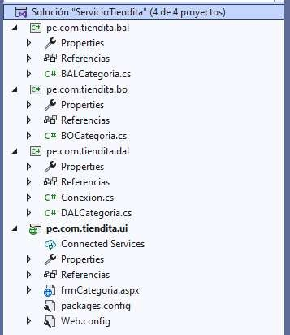

**Conexion.cs**

us ng System;

us ng System.Collect ons.Gener c; us ng System.Data.SqlCl ent;

us ng System.L nq; us ng System.Text;

us ng System.Thread ng.Tasks;

namespace pe.com.t end ta.dal

{

publ c class Conex on

{

//cadena de conex on

pr vate str ng cadena = "Data Source=.;In t al Catalog=bdt end ta;Integrated Secur ty=True";

pr vate SqlConnect on xcon; publ c SqlConnect on Conectar()

{

xcon = new SqlConnect on(cadena); xcon.Open();

return xcon;

}

publ c vo d CerrarConex on()

{

xcon.Close(); xcon.D spose();

}

}

}

# BOCategoria.cs

us ng System;

us ng System.Collect ons.Gener c; us ng System.L nq;

us ng System.Text;

us ng System.Thread ng.Tasks;

namespace pe.com.t end ta.bo

{

publ c class BOCategor a

{

publ c nt cod go { get; set; } publ c str ng nombre { get; set; } publ c bool estado { get; set; }

publ c BOCategor a()

{

}

}

}

# DALCategoria.cs

us ng pe.com.t end ta.bo; us ng System;

us ng System.Collect ons.Gener c; us ng System.Data;

us ng System.Data.SqlCl ent; us ng System.L nq;

us ng System.Text;

us ng System.Thread ng.Tasks;

namespace pe.com.t end ta.dal

{

publ c class DALCategor a

{

Conex on objconex on = new Conex on();

pr vate SqlCommand cmdcat; pr vate SqlDataReader drcat;

nt res = 0;

publ c L st<BOCategor a> MostrarCategor a()

{

L st<BOCategor a> categor as = new L st<BOCategor a>(); try

{

cmdcat = new SqlCommand();

cmdcat.CommandType = CommandType.StoredProcedure; cmdcat.CommandText = "SP_MostrarCategor a"; cmdcat.Connect on = objconex on.Conectar();

drcat = cmdcat.ExecuteReader(); wh le (drcat.Read())

{

BOCategor a objgen = new BOCategor a();

objgen.cod go = Convert.ToInt32(drcat["codcat"].ToStr ng());

objgen.nombre = drcat["nomcat"].ToStr ng(); objgen.estado =

Convert.ToBoolean(drcat["estcat"].ToStr ng());

categor as.Add(objgen);

}

return categor as;

}

catch (Except on ex)

{

Console.Wr teL ne(ex.ToStr ng()); return null;

}

f nally

{

objconex on.CerrarConex on();

}

}

publ c L st<BOCategor a> MostrarCategor aTodo()

{

L st<BOCategor a> categor as = new L st<BOCategor a>(); try

{

cmdcat = new SqlCommand();

cmdcat.CommandType = CommandType.StoredProcedure; cmdcat.CommandText = "SP_MostrarCategor aTodo"; cmdcat.Connect on = objconex on.Conectar();

drcat = cmdcat.ExecuteReader(); wh le (drcat.Read())

{

BOCategor a objgen = new BOCategor a(); objgen.cod go =

Convert.ToInt32(drcat["codcat"].ToStr ng());

objgen.nombre = drcat["nomcat"].ToStr ng(); objgen.estado =

Convert.ToBoolean(drcat["estcat"].ToStr ng());

categor as.Add(objgen);

}

return categor as;

}

catch (Except on ex)

{

Console.Wr teL ne(ex.ToStr ng()); return null;

}

f nally

{

objconex on.CerrarConex on();

}

}

publ c bool Reg strarCategor a(BOCategor a bc)

{

try

{

cmdcat = new SqlCommand();

cmdcat.CommandType = CommandType.StoredProcedure; cmdcat.CommandText = "SP_Reg strarCategor a"; cmdcat.Connect on = objconex on.Conectar();

cmdcat.Parameters.AddW thValue("@nombre", bc.nombre);

cmdcat.Parameters.AddW thValue("@estado", bc.estado); res = cmdcat.ExecuteNonQuery();

f (res == 1)

{

return true;

}

else

{

return false;

}

}

catch (Except on ex)

{

Console.Wr teL ne(ex.ToStr ng()); return false;

}

f nally

{

objconex on.CerrarConex on();

}

}

publ c bool Actual zarCategor a(BOCategor a bc)

{

try

{

cmdcat = new SqlCommand();

cmdcat.CommandType = CommandType.StoredProcedure; cmdcat.CommandText = "SP_Actual zarCategor a"; cmdcat.Connect on = objconex on.Conectar();

cmdcat.Parameters.AddW thValue("@cod go", bc.cod go); cmdcat.Parameters.AddW thValue("@nombre", bc.nombre); cmdcat.Parameters.AddW thValue("@estado", bc.estado);

res = cmdcat.ExecuteNonQuery();

f (res == 1)

{

return true;

}

else

{

return false;

}

}

catch (Except on ex)

{

Console.Wr teL ne(ex.ToStr ng()); return false;

}

f nally

{

objconex on.CerrarConex on();

}

}

publ c bool El m narCategor a(BOCategor a bc)

try

{

cmdcat = new SqlCommand();

cmdcat.CommandType = CommandType.StoredProcedure; cmdcat.CommandText = "SP_El m narCategor a"; cmdcat.Connect on = objconex on.Conectar();

cmdcat.Parameters.AddW thValue("@cod go", bc.cod go); res = cmdcat.ExecuteNonQuery();

f (res == 1)

{

return true;

}

else

{

return false;

}

}

catch (Except on ex)

{

Console.Wr teL ne(ex.ToStr ng()); return false;

}

f nally

{

objconex on.CerrarConex on();

}

}

}

}

# BALCategoria.cs

us ng pe.com.t end ta.bo; us ng pe.com.t end ta.dal; us ng System;

us ng System.Collect ons.Gener c; us ng System.L nq;

us ng System.Text;

us ng System.Thread ng.Tasks;

namespace pe.com.t end ta.bal

{

publ c class BALCategor a

{

DALCategor a dalcat = new DALCategor a();

publ c L st<BOCategor a> MostrarCategor a()

{

return dalcat.MostrarCategor a();

}

publ c L st<BOCategor a> MostrarCategor aTodo()

{

return dalcat.MostrarCategor aTodo();

}

publ c bool Reg strarCategor a(BOCategor a bc)

return dalcat.Reg strarCategor a(bc);

}

publ c bool Actual zarCategor a(BOCategor a bc)

{

return dalcat.Actual zarCategor a(bc);

}

publ c bool El m narCategor a(BOCategor a bc)

{

return dalcat.El m narCategor a(bc);

}

}

}

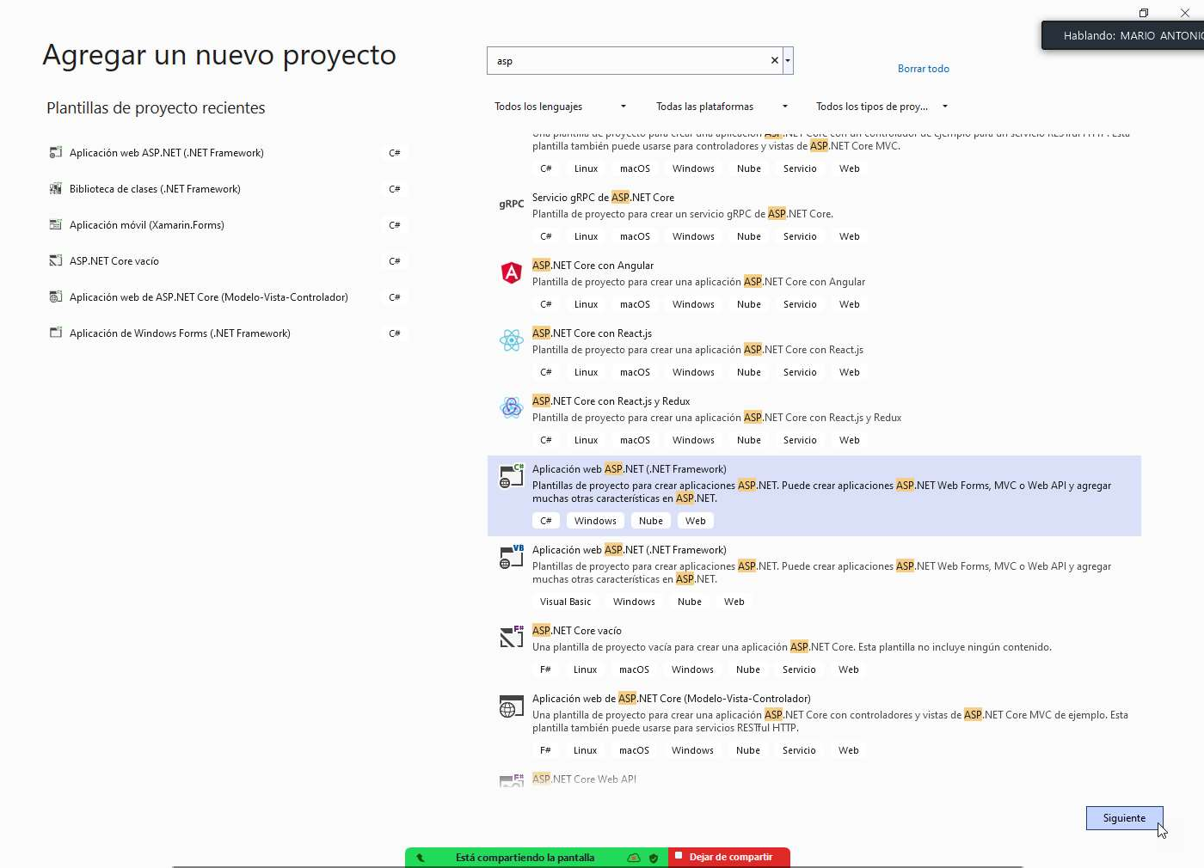

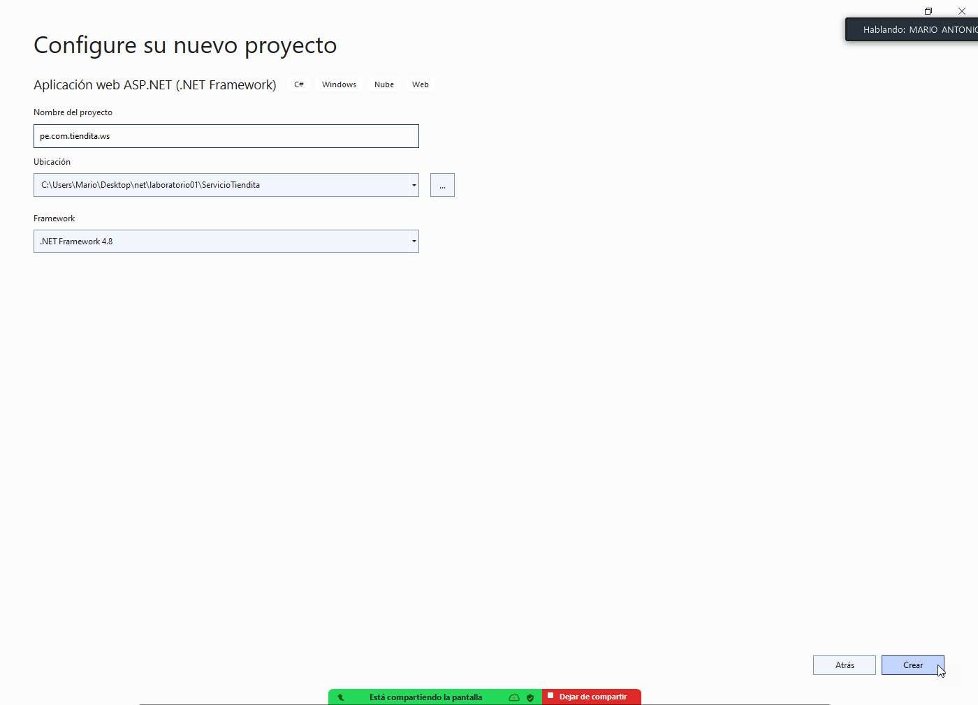

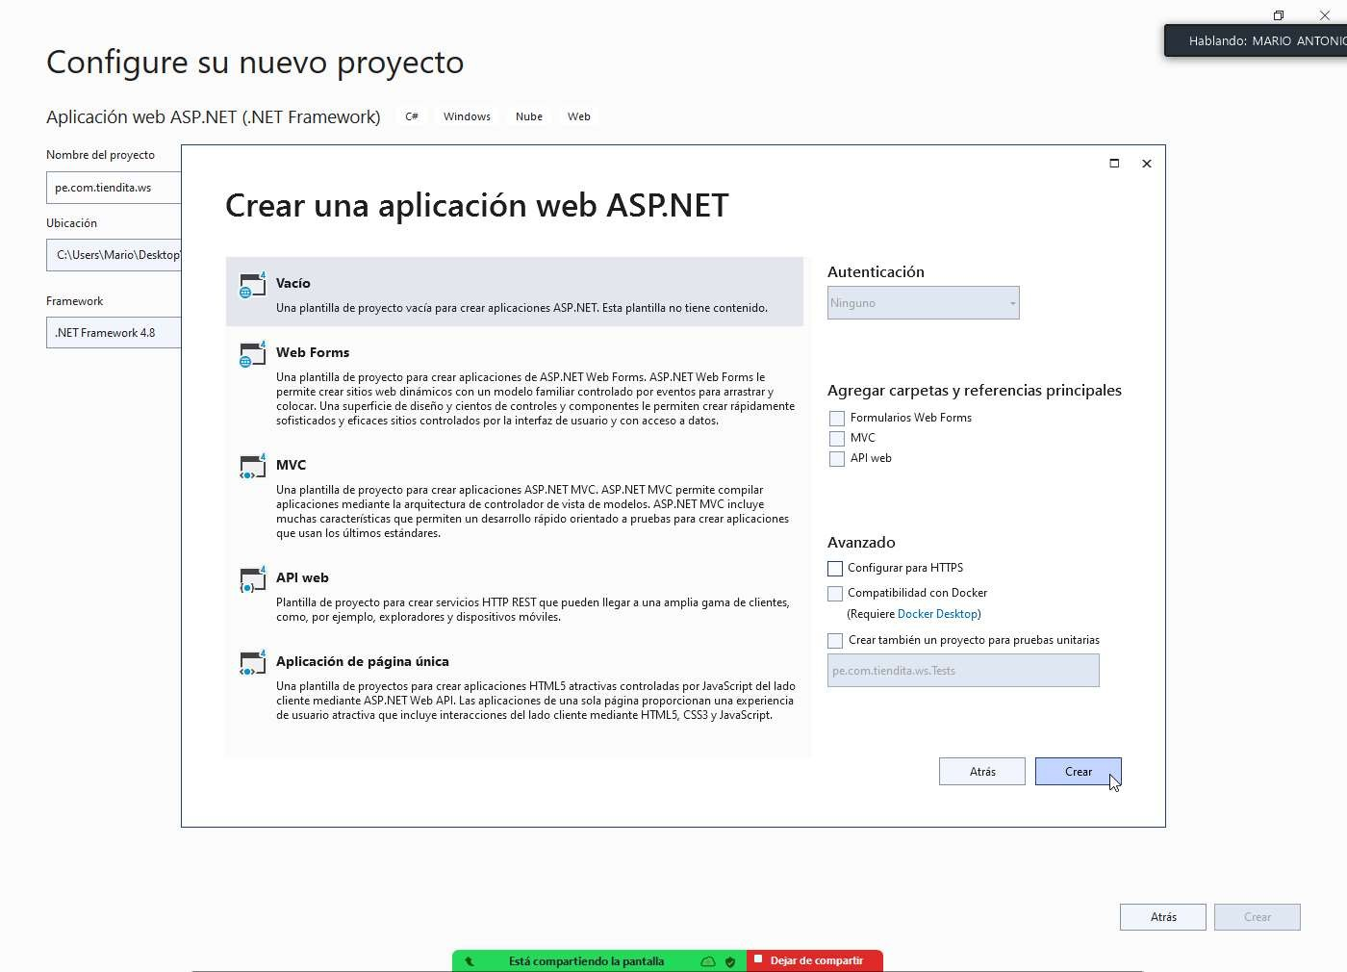

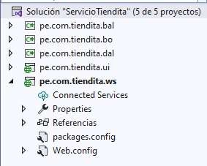

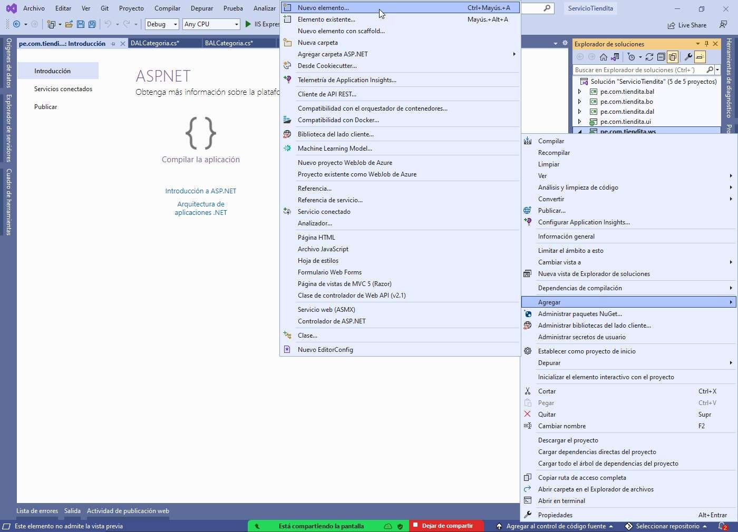

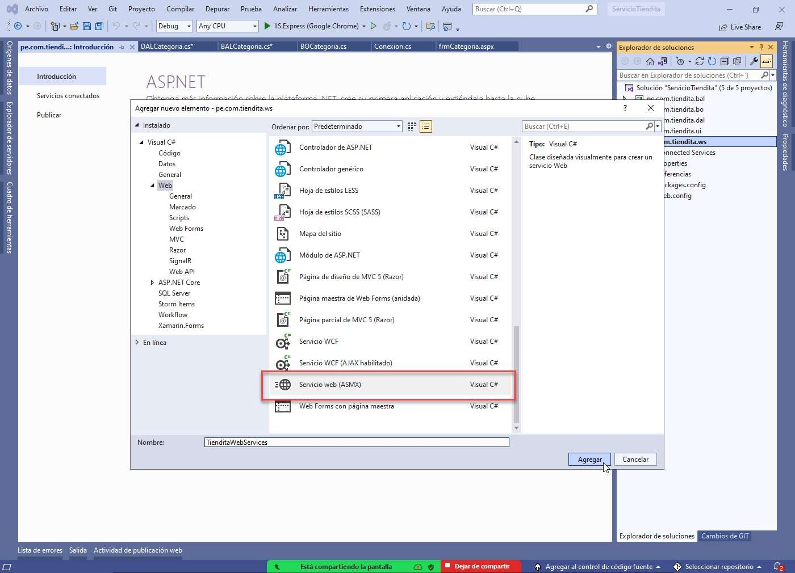

# TienditaWebServices

us ng pe.com.t end ta.bal; us ng pe.com.t end ta.bo; us ng System;

us ng System.Collect ons.Gener c; us ng System.L nq;

us ng System.Web;

us ng System.Web.Serv ces;

namespace pe.com.t end ta.ws

{

/// <summary>

/// Descr pc ón breve de T end taWebServ ces

/// </summary>

[WebServ ce(Namespace = "[http://tempur](http://tempur/) .org/")]

[WebServ ceB nd ng(ConformsTo = Ws Prof les.Bas cProf le1_1)] [System.ComponentModel.ToolboxItem(false)]

// Para perm t r que se llame a este serv c o web desde un scr pt, usando ASP.NET AJAX, qu te la marca de comentar o de la línea s gu ente.

// [System.Web.Scr pt.Serv ces.Scr ptServ ce]

publ c class T end taWebServ ces : System.Web.Serv ces.WebServ ce

{

BOCategor a bocat = new BOCategor a(); BALCategor a balcat = new BALCategor a();

[WebMethod]

publ c L st<BOCategor a> MostrarCategor a()

{

L st<BOCategor a> categor as = balcat.MostrarCategor a().ToL st();

return categor as;

}

[WebMethod]

publ c L st<BOCategor a> MostrarCategor aTodo()

{

L st<BOCategor a> categor as = balcat.MostrarCategor aTodo().ToL st();

return categor as;

}

[WebMethod]

publ c bool Reg strarCategor a(BOCategor a bc)

{

return balcat.Reg strarCategor a(bc);

}

[WebMethod]

publ c bool Actual zarCategor a(BOCategor a bc)

{

return balcat.Actual zarCategor a(bc);

}

[WebMethod]

publ c bool El m narCategor a(BOCategor a bc)

{

return balcat.El m narCategor a(bc);

}

}

}